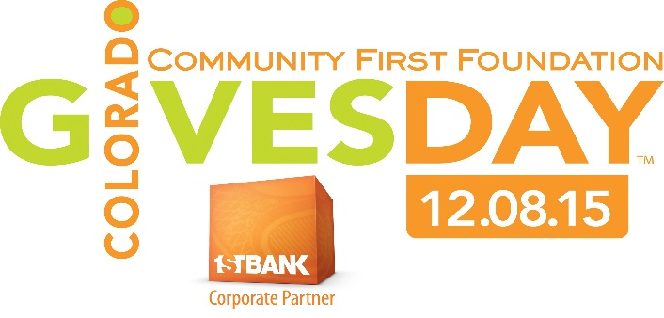
If Each Family gave $30 on Colorado Gives Day…
Then Highline can ensure:
- Small class sizes
- Strong Liberal Arts
- Increased technology
- Rigorous Education
Colorado Gives Day is an annual state-wide movement to celebrate and increase philanthropy through online giving. Every nonprofit receiving a donation on Colorado Gives Day receives a portion of the $1 million incentive fund, which increases the value of every dollar donated.
The funding that Highline receives from the State is not enough to meet our needs. We have a
$85,000
2015-16 fundraising goal of :
to help maintain our strong
educational values.
- If every family gave a one-time donation of $234,
we would REACH our goal for the YEAR
- Your family may choose to sponsor another family
- REACH Out to local businesses to ask if they could
donate to Highline on Colorado Gives Day. Please
stop by the front office to pick up a Donor Sheet.

How it works: All donors must type “SOUTHEAST”in the
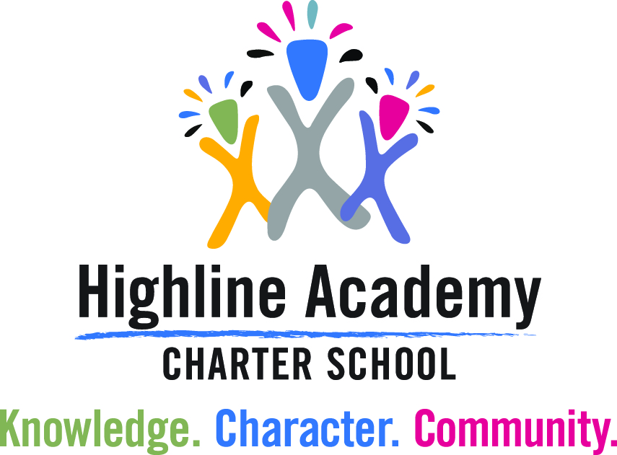
Special Instructions section to ensure that funds go
directly to the Southeast campus.
- Log on to www.coloradogives.org
- Search for Highline Academy
- Click DONATE NOW
- Enter donation amount
- Donation type: CO Gives Day
- Complete all other fields below

Thank you for your donation to Highline
on December 8th for CO Gives Day!

